**Hybrid Maize Varieties (*Zea mays L.)* Selection in Nepal: Stability Analysis Under Cold wave escape & Cold-Wave Conditions Using AMMI, BLUP, GGE Biplot, MTSI.**

Chitra Bahadur Kuwar**1**, Bikas Basnet**2**, Samjhana. Sunuwar**3**, Deep Narayan Mahato**4**, Ramdas Chaudhari**5** Jharna Upadhya**1a**, Pragya Pokhrel**1a**

**1**Maize Coordinator, Seiner scientist (S4), National Maize Research Program, Rampur, Chitwan, Nepal.

**1a**National Maize Research Program, Rampur, Chitwan, Nepal.

**2\***Faculty of Agriculture, Agriculture and Forestry University, Bharatpur, Nepal.

**3**Regional Agriculture Research Station, Tarahara, Nepal

**4**Regional Agriculture Research Station, Parwanipur, Nepal

**5**Regional Agriculture Research Station, Nepalgunj, Nepal

*Corresponding author email: [bikasbasnet2001@gmail.com](mailto:bikasbasnet2001@gmail.com)

*Bikas Basnet Orchid id: 0000-0003-0579-6039

**Abstract**

A winter trial in Nepal tested varied maize hybrids for yield and stability across four stations, considering both cold waves and escape condition. Employing a complete block design with 3 replications each station, the study revealed significant(P<0.001) impacts of genotype, environment, and their interaction (GEI) on yield. This GEI, accounting for 100% of yield variance, was mainly captured by three principal components, with the first explaining 49%. Notably, mixed-effects models and biplots identified superior hybrids exhibiting both high average yields and consistent performance. GGE biplot analysis unveiled high-yielding and adaptable champions: GK3157, NK6607, RMH1899 Super, GK3254, RMH666, Shan 111, DKC9149, and Sweety-1. BLUP and WAASB analyses delineated the superior performers and stabilized varieties for yield, with DKC9141, Uttam 121, NK6607, MM2929, and MM2023, RMH-666, GK 3254, and GK3157, and RMH-1899, RMH1819-super as top candidates for both high yield and stability. In Nepalgunj, Delta 3333, MM2122, and Shaan 111 excelled in both yield and stability, while Rampur favored Rampur Hybrid 6 and MM2424 for stability. Parwanipur and Tarahara shared similar winners for stability and yield, including MM2122, Shaan 111, and Delta 3333 in Parwanipur, and NK7884, MM2424, and Delta 2222 in Tarahara. Based on Multi genotype ideotype distance (MGDI), 9 varieties were selected for yield and stability, including MM 2033, NK 6607, MM 2929, Sweety 1, NK 6702, NK 7660, Uttam 121, GK 3203, and MM 2050 exhibits **escape to cold waves** whereas GK3254, TMMH-846, and MM-9442, were chosen for their suitability for cultivation in environments with frequent cold waves.

**Keywords**: **Mixed-effects models**, **Yield stability, Genotype-environment interaction, Cold wave, Nepal.**

1. **Introduction**:

Scientists have discovered the historical background of maize and have ascertained that its predecessors possessed a total of 10 chromosomes(Wei et al., 2007). After conducting a thorough analysis of duplicated genes, it has been revealed that the origin of maize is not a result of self-duplication but rather a consequence of hybridization with approximate size of the maize genome is 2.4 Gb(Haberer et al., 2005). Around 9,000 years ago, maize underwent the process of domestication through a singular event in southern Mexico, specifically derived from Balsas river teosinte (*Zea mays ssp. parviglumis*). parviglumis)(Yang et al., 2019). The teosinte seed is covered by a remarkably tough fruitcase that makes it very hard to eat. However, the presence or absence of the fruitcase is primarily determined by a single gene known as the fruitcase gene, which is classified as a unique type of regulatory gene- teosinte glume architecture or tga1, (and therefore, the impact of a single gene can be remarkably transformative)(Yang et al., 2019)(Wang et al., 2005). Another question remains: why would anyone ever grow teosinte, which doesn't seem like a very good crop? Anthropologist George Hill suggests a possible answer: its popcorn-like popping ability. This characteristic might have made the seeds easier to digest and unlock their nutritional value, attracting early farmers to grow as food crop (Biointeractive, 2015).

The global maize yield has experienced an almost threefold increase since 1961, rising from 2 tons per hectare to the current figure of 5.8 tons per hectare(Erenstein et al., 2022). It is anticipated that the United States will emerge as the foremost corn producer on a global scale in the year 2022/2023, boasting a substantial production volume of approximately 348.75 million metric tons. China and Brazil conclude the list of leading corn-producing nations (Shahbandeh, 2023). Within Nepal during the timeframe of 2020-21, the area and production of maize are reported to amount to 979,776 hectares and 2,997.733 metric tons (equivalent to 3.06 tons per hectare)(Promotion et al., 2012). Biofortification, an approach involving the identification and frequent multiplication of quantitative trait loci (QTLs), offers a practical solution to combatting hidden hunger among underprivileged populations and ensuring their nutritional security. Several maize varieties, such as ICTA HB-18, ICTA B-15, and BIO-MZN01, have been successfully biofortified with essential micronutrients like iron, zinc and PVAH 1-100 series for carotenoids (Basnet & Khanal, 2022)(Beswa et al., 2020).

Chilling stress harms maize by hindering growth, affecting reproduction, and lowering seed quantity. Seed priming with Salicylic acid (20mg/l) significantly boosted yield by 25% under this stress(Waqas et al., 2021). Chilling early in pollen development didn't hurt individual anther pollen output, but Dent11 tassels chilled during earlier growth stages made 43-29% fewer pollen grains overall(Tranel et al., 2009). Extreme cold destroyed Nepal's winter maize crop, causing massive losses for farmers. Hybrid maize lost almost all its yield, and over 12,000 farmers lost a total of Rs 107.38 million Madhesh Province of Nepal (Republica, 2018). Facing **hefty** economic losses, Nepal's National Maize Research Program (NMRP) investigated the performance and stability of hybrid maize varieties from multinational companies. This study employed cutting-edge methods to assess how well these hybrids-maintained yield across diverse environments. To identify promising varieties, the study utilized four different models, each chosen for its unique strengths and weaknesses. Although the AMMI stability model is a graphic-based tool for modeling GEI, it is unable to take into account a linear mixed-effect model within the structure(Olivoto & Lúcio, 2020). AMMI struggles to incorporate random effects and structured relationships between environments, which are essential features of LMMs. This can lead to biased estimates and limit its applicability in complex scenarios(Taleghani et al., 2023). Best Linear Unbiased Prediction although BLUP is not a graphic-based tool to manage random GEI structure, it can produce accurate response estimates. A mixed-model version of AMMI, WAASB takes into account all IPCA (interaction Principle components axes for stability analysis and treats varieties as random variables(Munda et al., 2023). The most widely used stability index, the AMMI Stability Value (ASV), is based on squared deviations. The WAASB index is more resilient and insensitive to outliers because it is based on absolute deviations(Ndhlela et al., 2014)(*WAASB Based Stability Analysis and Simultaneous Selection for Grain Yield and Early Maturity in Soybean*, n.d.). MTSI (Multi-Trait Stability Index) is a method used to select high-yielding and stable varieties in multi-environment trials. Compared to AMMI, BLUP, and GGE biplot, MTSI has the advantage of considering both mean performance and stability simultaneously because it takes into account the correlation structure among variables(Olivoto et al., 2021). Varieties with performance closer to the ideal, as determined by their position in the factor analysis results, receive higher MTSI scores(Benakanahalli et al., 2021).

High genotype-environment interaction for grain yield complicates the search for superior Maize hybrids that perform consistently across diverse environments. Modernizing Nepal's maize sector requires identifying stable, high-yielding varieties. This innovative research fills a critical gap by utilizing stability analysis methods to select ideal varieties for wider cultivation and recommendation. In Nepal only 17% opting for hybrid maize varieties rests of OPV(Gairhe et al., 2021). Agrovet became a hub for cheap multinational hybrid seeds. Harrowing winter cold waves, known as "sitlahar" results on leaving fields littered with barren cobs. In response, the government, determined to safeguard farmer livelihoods, implemented new regulations. These directives tasked the Nepal Agriculture Research Council (National Maize Research Program, Rampur, Chitwan, Nepal) with a critical mission: rigorously evaluate the stability and performance of commercially available maize hybrids under frigid cold waves Across varied locations. This study evaluates optimal maize genotypes for resilience under cold waves stressful conditions because minimum temperatures for pollen abortion range from below 10 °C(SHAO et al., 2021)(Waqas et al., 2021). Nepal's Terai region have special climate called "sitlahar" in winter and "Lu". A Studies show a significant increase in cold days and extreme cold waves over the past 40 years. January, February, and December are most risky month for the cold waves and extreme waves in the Terai region of Nepal. On average, the Terai experiences 9.2-13.8 cold wave days and 1.4-3.8 extreme cold wave days each year(Shrestha et al., 2023). In **Nepal there is no used of such cutting edges** methodologies and **investigation** of maize hybrids on **4** locations of Nepal under cold waves tolerant genotypes and superior performers in yield.

1. **Materials and Methods:**
   1. **Plant materials, experimental site & design**

A total of 45 maize hybrids from multinational companies and NMRP were evaluated in a two-year experiment (2020-2022) across diverse climates in Nepal. Four research stations representing the east (humid, Tarahara), intermediate (Bara, Pawanipur), maize research hub (Chitwan), and far west (dry, Nepalgunj) were used. A randomized block design with three replications and factor levels was employed. Optimizing yield was the goal, with a spacing of 60x25cm between plants and rows of 5 meters. This resulted in a planting density of 66666 plants per hectare. Sowing was conducted from 13 to 23 November in both years, moving from east to west.

* 1. **Climate data to study cold wave**

In the experiment periods Maize anthesis, the flowering stage, typically occurs between February 23rd and the first week of March in Nepal. To investigate the potential impacts of cold waves on this crucial stage, a line graph will be used to visualize the minimum and maximum temperatures recorded at four research stations *Figure 1*. Temperature data was obtained from the Department of Hydrology and Meteorology, Babarmahal, Kathmandu, Nepal.

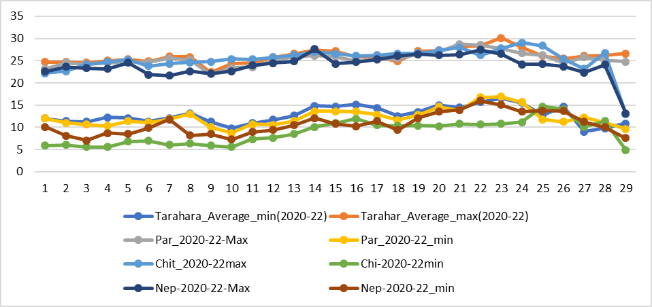

Figure 1 Figure depicting the weather patterns from February 2020 to 2022 that coincide with the Days to Anthesis of hybrid maize varieties

* 1. **Statistical analysis**

The data was entered into Excel and subsequently analyzed using R programming (R version 4.3.1 (2023-06-16 ucrt)). The metan package was employed for AMMI, GGE, BLUP, and MTSI model analysis. Joint analysis of variance (ANOVA) was used for pooled analysis. For the AMMI model, the performs_ammi function facilitated multiplicative interaction analysis, while plot_scores and ammi_indexes functions were utilized for AMMI biplot visualization and index value calculation, respectively. Index types 3, 4, 6, 8, and 10 were used for environment calculations (stability, representativeness, ranking, genotype ranking, and environmental relationships, respectively). The 'gge' function provided insights into genotype performance and stability across environments, and plot_waasby generated WAASBY plots. BLUP analysis was achieved using the gamem_met function. Finally, ggplot2's ggsave function enabled high-resolution figure export. Code used for this study is deposited on git-hub libraries(<https://github.com/Bikasbasnettest/PCA-cluster-biplot-AMMI-MTSI-WASB-ANALYISS-CODE->)

* 1. **For linear mixed model:**

$y=Xβ+Zu+e…………………………………………………………….$

where β is the data vector of the fixed unknown effect (the average value of the block in each environment), u is the GEI + genotype effect, X and Z represent the matrix involving β, u, and Y, and ε is the random error vector(Olivoto & Lúcio, 2020).

* 1. **Additive Main effects and Multiplicative Interaction**

Compute the Additive Main effects and Multiplicative interaction (AMMI) model. The estimate of the response variable for the ith genotype in the jth environment () using the AMMI model, is given as follows:

$$y_{ij}= μ+α_{i}+r_{j}+\sum_{k=1}^{p}{λ_{k}α_{ik}t_{jk}+p_{ij+ε_{ij}}}…………………………$$

where λk is the singular value for the kth interaction principal component axis (IPCA); αik is the ith element of the kth eigenvector; tjk is the jth element of the kth eigenvector. A residual pij remains if not all p IPCA are used, where p ≤min(g-1;e-1)(Ndhlela et al., 2014).

* 1. **Weighted Average of Absolute Scores:**

Compute the Weighted Average of Absolute Scores (Olivoto et al., 2019) for quantifying the stability of *g* varieties conducted in *e* environments using linear mixed-effect models. The weighted average of absolute scores is computed considering all Interaction Principal Component Axis (IPCA) from the Singular Value Decomposition (SVD) of the matrix of genotype-environment interaction (GEI) effects generated by a linear mixed-effect model, as follows:

$${WAASB}_{I}=\sum_{K=1}^{p}{{|PCA}_{jk}x{EP}_{K}|\frac{1}{\sum_{K=1}^{P}{{EP}_{K}}}…………………………. }$$

where WAASBi is the weighted average of absolute scores of the ith genotype; IPCAjk  is the score of the ith genotype in the kth Interaction Principal Component Axis (IPCA); and is the explained variance of the kth IPCA for k = 1,2,..,p, considering p ≤min(g-1;e-1)(Olivoto et al., 2019).

* 1. **Multi-Trait Genotype-Ideotype Distance Index (MTGID)**

$${\dot{MGIDI}}_{i}=\sqrt{\sum_{j=1}^{f}{{\left(Fij-Fj\right)}^{2}……………………………………………………}}$$

Where ${\dot{MGIDI}}_{i}$ represents the index of multi-trait genotype-ideotype distance for the ith genotype. $F_{ij}$ represents the score assigned to a given genotype concerning a specific factor, denoted by "i" for the ith genotype and "j" for the jth factor. The variables g and f correspond to the total number of varieties and factors included in this analysis, $F_{ij}$ is the **jth** score of the ideotype. The genotype exhibiting the lowest MGIDI is more proximate to the ideotype and, consequently, is expected to showcase desirable values for all scrutinized traits(Olivoto & Nardino, n.d., 2021).

The proportion of the MGIDI index for the ith row (representing genotype or treatment) explained by the jth factor (xij) is utilized to assess the strengths and weaknesses of varieties. This proportion is computed as

$$wij= \sqrt{\frac{D^{2}ij}{\sum_{j=1}^{f}{D^{2}}}……………………………………………………………..}$$

1. **Results and Discussion**
   1. **Combined analysis of variance of AMMI model**

The impact of environmental factors and the genetic makeup of maize plants on yield was found to be statistically significant, as determined by a comprehensive analysis of variance (ANOVA). The observed significance level (p < 0.05) underscores a robust influence of these factors on maize yield. similar results was obtained for the grain yield of maize by (Ndhlela et al., 2014). Subsequent joint ANOVA analysis revealed key statistical parameters, including a coefficient of variation (CV) of 11.47%, indicative of the yield's relative variability. The residual standard error, measuring the dispersion of data points around the fitted regression line, was determined to be 0.82. The analysis of interaction effects demonstrated a mean sum of positive and negative interactions (MSR+/MSR-) of 3.43, signifying the combined impact of environmental and genetic factors on yield variation. Further decomposition through principal component analysis (PCA) elucidated the total variance in yield. Three interaction principal components collectively accounted for 100% of the total variance. The first principal component explained 49% of the total variance, highlighting its substantial contribution. The second principal component contributed 28.4%, with a combined contribution of the first two components amounting to 77.4% of the total variance ***Table 1***.

**Table 1 AMMI model ANOVA for Grain Yield (t/ha) Across Locations (2020-2022)**

|  |  |  |  |  |  |  |  |
| --- | --- | --- | --- | --- | --- | --- | --- |
| Source | Df | Sum Sq | Mean Sq | F value | Pr(>F) | Proportion | Accumulated |
| ENV | 3 | 28.418 | 9.472617 | 75400 | 0.00E+00 | NaN | NaN |
| REP(ENV) | 8 | 0.001 | 0.000126 | 0.0002 | 1.00E+00 | NaN | NaN |
| GEN | 42 | 392.27 | 9.33975 | 11.4 | 1.74E-57 | NaN | NaN |
| GEN:ENV | 126 | 368.599 | 2.925387 | 3.56 | 4.39E-28 | NaN | NaN |
| PC1 | 44 | 90.28 | 2.05181 | 2.5 | 0.001E-01 | **49** | 49 |
| PC2 | 42 | 52.324 | 1.2458 | 1.52 | 1.96E-02 | **28.4** | 77.4 |
| PC3 | 40 | 41.696 | 1.0424 | 1.27 | 1.25E-01 | **22.6** | 100 |
| Residuals | 852 | 700.023 | 0.821624 | NA | NA | NA | NA |
| All variables with significant (p < 0.05) genotype-vs-environment interaction Done! | | | | | | | |

* 1. **AMMI (1 and 2) biplot analysis for Maize Hybrid Yield analysis**

The AMMI1 **bi-plot** helps visualize the genotype by environment interaction (GEI) effect by plotting the mean yields of environments and varieties against their respective IPCA1 scores(Khan et al., 2021). The x-axis of the **bi-plot** represents the average yield, with points to the right indicating higher-yielding varieties and environments, and points to the left indicating lower-yielding varieties and unfavorable, low-yielding environments(Yan & Tinker, 2006). The y-axis of the biplot represents the IPCA1 score, which measures the contribution of the GEI effect to the overall yield variation. Varieties and environments that are farther away from the origin of the biplot have a stronger GEI effect, meaning their yield performance varies more across different environments(Gebreselassie et al., 2023). The selection of superior genotypes in crop breeding is primarily focused on the pivotal trait of yield(Gauch, 2013). The AMMI1 plot illustrates that varieties such as NK6607, GK3157, GK-3203, RMH-666, and RMH1819-super exhibit resilience and high productivity for yield. In contrast, Rajkumar, TX-369, and Delta-5555 are stable for yield but fall below the threshold, indicating their unsuitability for selection as major phenotypes aimed at maximizing yield. Furthermore, MM2033, DKC9141, DKC9144, RMH-9999, and NK6702 demonstrate high yields but are positioned far from the origin, rendering them unstable and, consequently, unsuitable for commercial cultivation. In AMMI Plot 1, the vector length of an environment indicates the degree to which it contributes to and influences the genotype by environment interaction (GEI) captured by the first principal component axis (IPCA1)(Krishnamurthy et al., 2017).Thus Location Tarahara have larger vector length indicates that the higher the discriminatory ability of the environment, indicating that the environment has a stronger impact on the genotype-by-environment interaction followed by Parwanipur and Nepalgunj. Rampur have shorter vector length indicates lower the discriminatory ability of the environment, suggesting that the environment has a weaker impact on the genotype-by-environment interaction. Rampur is regarded as the perfect index for selection of consistent and high yielding genotypes.

The AMMI2 biplot, depicting principal component axes (IPCA1 and IPCA2), illuminates the nature and magnitude of genotype-environment interactions (GEIs) in the study(Gebreselassie et al., 2023)(Singh et al., 2019). With 48.9% and 28.4% of the total variance explained by IPCA1 and IPCA2, respectively, the cumulative contribution reaches 77.3% *Figure 6*. Notably, Nepalgunj exhibits the greatest distance from the origin, followed by Parwanipur and Tarahara, indicating their stronger influence on GEIs. In contrast, Rampur displays the shortest vector, suggesting a relatively weaker impact on interaction patterns. Genotype performance also reveals distinct patterns across environments. DKC9141 emerges as the top-yielding variety in Parwanipur, while RMH-567 dominates in Rampur. Tarahara showcases Uttam 121 and RH-10 as the highest performers, and Nepalgunj witnesses Rampur Hybrid 6, NK7884, and MM2033 achieving the highest yields. These observations highlight the crucial role of environment-specific adaptation in determining genotype performance.

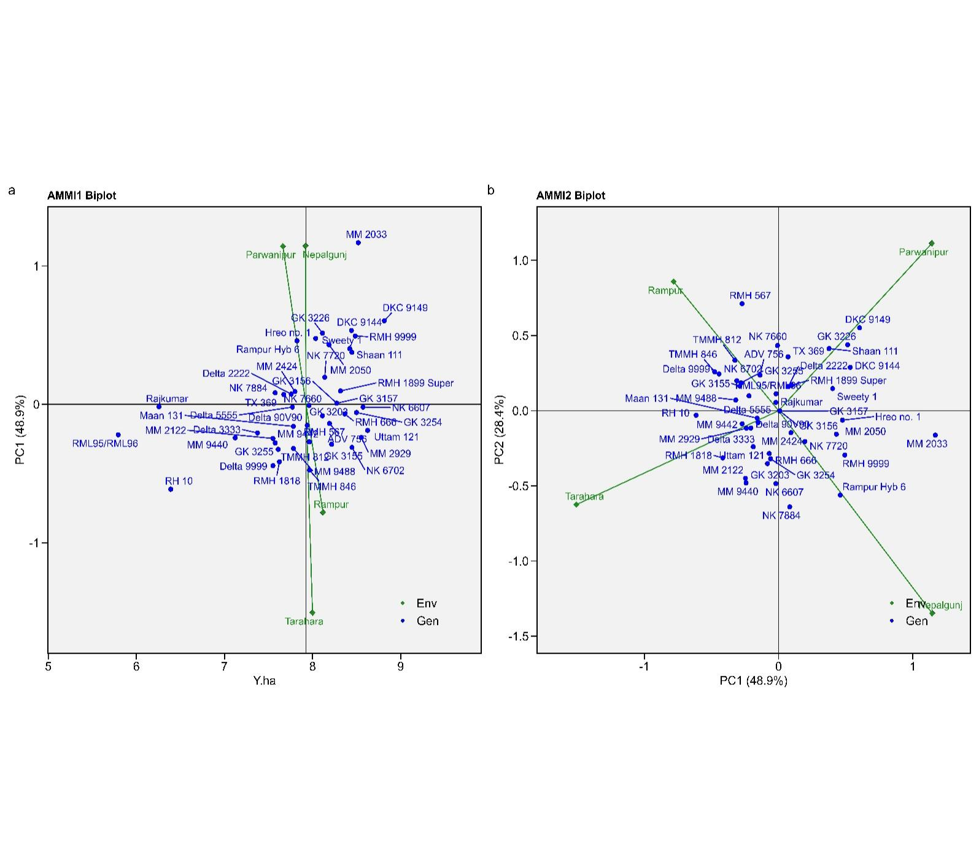

Figure 6 AMMI 1 and 2 Biplot depicting the performance of multinational companies' maize varieties for grain yield/ha across four diverse environments.

* 1. **Which won where biplot**

Seven vertex varieties, namely MM2929, NK6702, TMMH-846, RH-10, RML-95/96, MM-2033, DKC-9149 were connected to form a polygon, representing their grain yield performance. The application of a "which-won-where" approach in a sorghum investigation revealed the presence of three mega-environments characterized by different optimal cultivars(Rakshit et al., 2012). Six lines drawn from the biplot's origin, intersecting the polygon's sides perpendicularly, divided the biplot into eight regions. Environments were categorized into two sectors based on their yield similarities, implying a potential division into two mega-environments. The most responsive genotype was the one with the farthest vertex from the biplot origin, exhibiting the highest yield among the environments within its sector. The first mega-environment comprised two environments: Parwanipur, and Nepalgunj. Varieties MM2033 and DKC-9149 stood out as the winners in the 1st mega-environment, whereas MM2929, NK-6702 are winner for Rampur and Tarahara, both possessing the longest vector lengths within their respective mega-environments *Figure 7*.

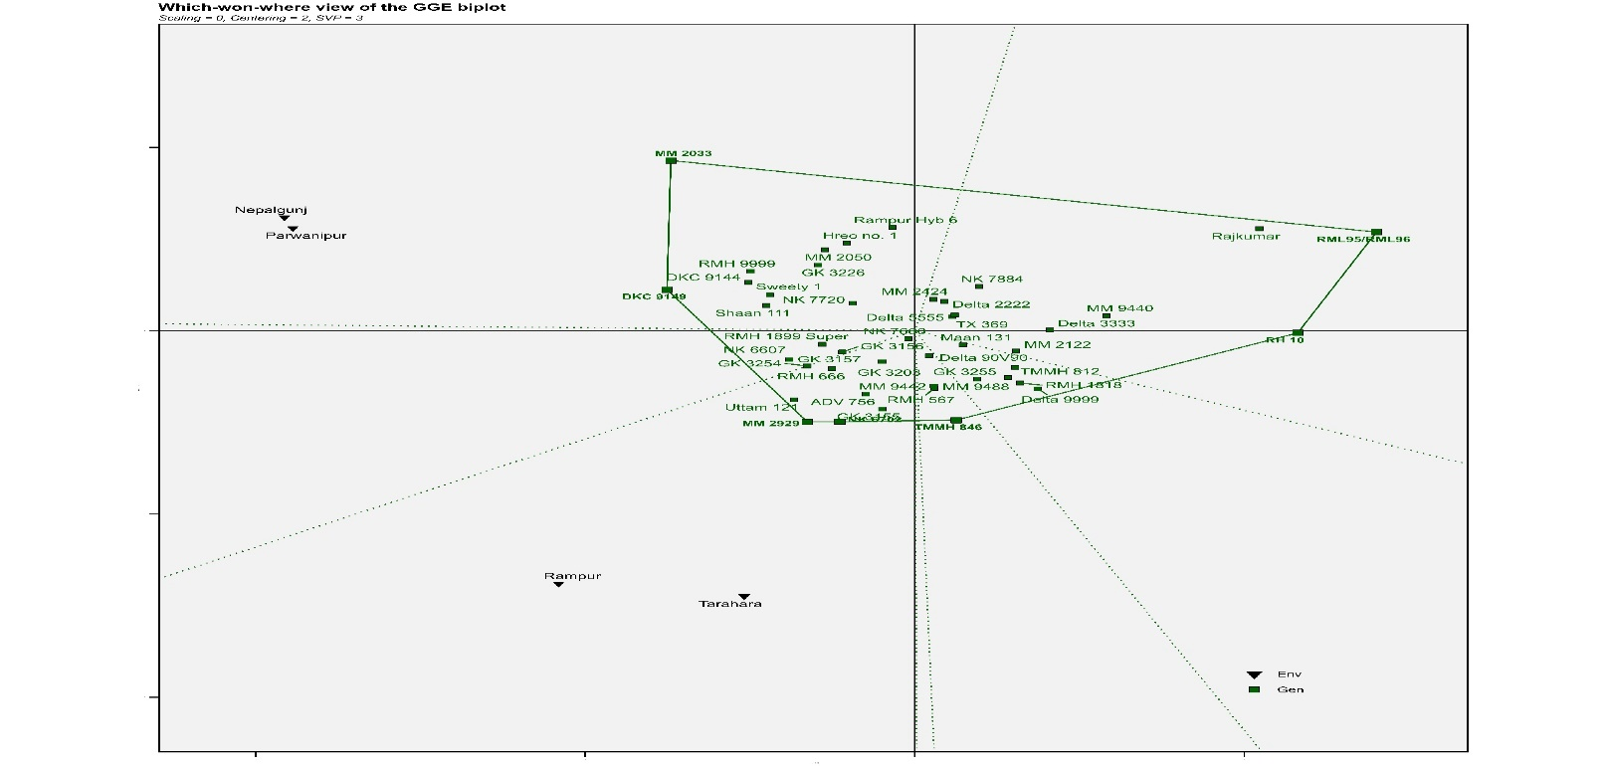

Figure 7 Polygons of the GGE biplot method were used to determine the "which-won-where" pattern (genotypes-environment) based on grain yield per hectare.

* 1. **GGE biplot for Specific location winner varieties**

Principal component analysis reveals that the first and second components explain 58.51% and 17.24% of the total variance, respectively, for a cumulative total of 75.75%. In Nepalgunj, genotypes like Delta 3333, TMMH-812, MM2122, Mann 131, Delta 3535, NK7720, Shaan 111, Sweety 1, DKC9144, and DKC9149 emerged as winners in terms of both stability and yield. Meanwhile, Rampur Hybrid 6, TX-369, MM2424, Delta 2222, and NK7884 proved stable in Rampur. Moving to Parwanipur, MM9440, Delta 3333, MM2122, Maan-131, Shaan 111, DKC 9149, and Sweety 1 displayed stability. Finally, in Tarahara, varieties NK7884, MM2424, Delta 2222, TX.369, and Delta 5555 achieved both stability and high performance *Figure 8*. These findings offer valuable insights into the selection of suitable genotypes for different rice-growing regions in Nepal.

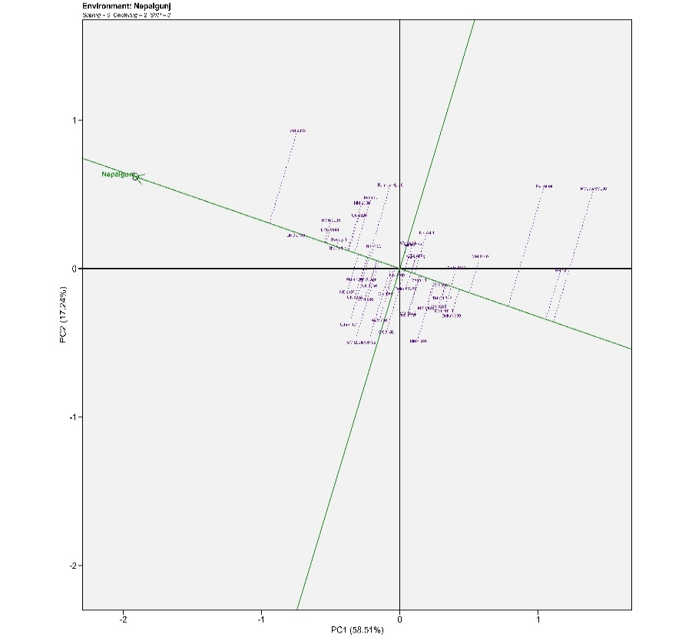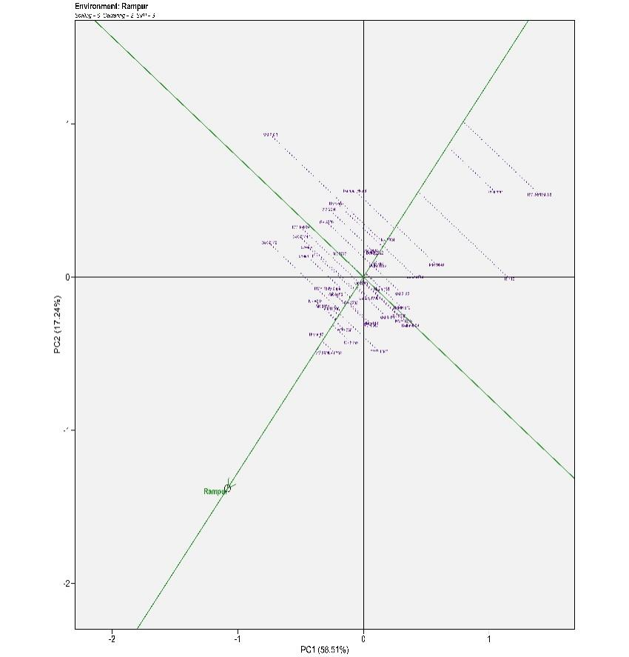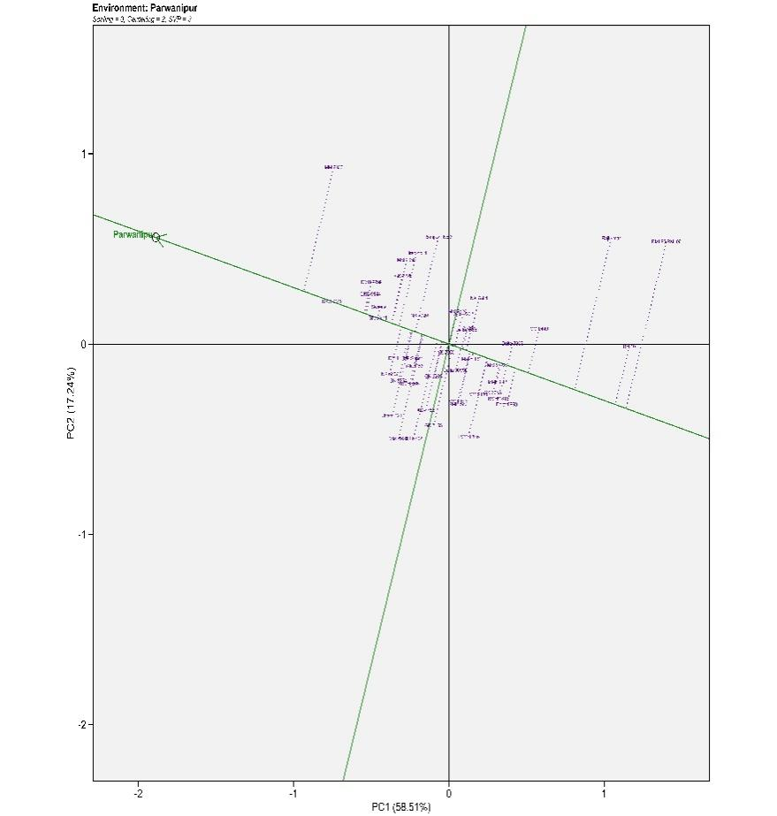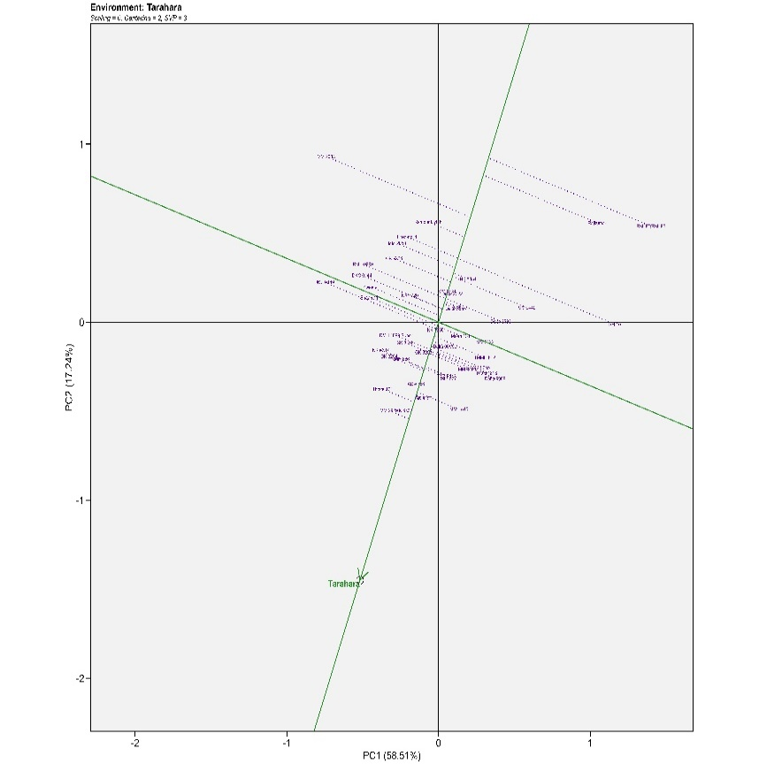

Figure 8 GGE biplot illustrating genotype-by-environment interactions for winner genotypes across Nepalgunj(I), Rampur(II), Parwanipur(III), and Tarahara(IV) for the 2019-2021 growing seasons.

I

II

III

IV

* 1. **Discriminativeness vs Representativeness of the Environments over Genotypes**

The discriminate versus representativeness biplot, showcased in *Figure 9*, serves as a valuable GGE biplot for assessing test environments(Gebreselassie et al., 2023)(Adham et al., 2022). Environments with high discriminating ability are adept at distinguishing between varieties based on their performance. Environments in this study were carefully chosen to effectively separate maize varieties with different yield potentials, leading to precise identification of high-performing ones. But how representative are these environments? Representativeness refers to how similar a test environment's results are to other environments. Here, the angle between a test environment and the "average environment" serves as a dual measure of both representativeness and discriminating ability(Esan et al., 2023). A small angle indicates high representativeness (similar to the average) and low discriminating ability (varieties perform similarly), while a larger angle suggests the opposite: low representativeness (unique environment) and high discriminating ability (varieties perform distinctly)(Khan et al., 2021). Rampur and Parwanipur stand out as more representative environments compared to Nepalgunj and Tarahara, while the latter pair, along with Parwanipur, are the most discriminating. This relationship flips for representativeness, with DKC-9149 and Shann-111 taking the reins for discriminating ability, while GK3157, RMH-666, MM2929, and GK3203 shine in representativeness. Highly discriminating environments are crucial for identifying varieties with stable yields and specific adaptations. This explains why the acute angles between all environments in this study suggest positive correlations: Nepalgunj and Parwanipur show the strongest positive correlation, followed by Rampur and Tarahara. In other words, genotypes tend to perform similarly across these environments.

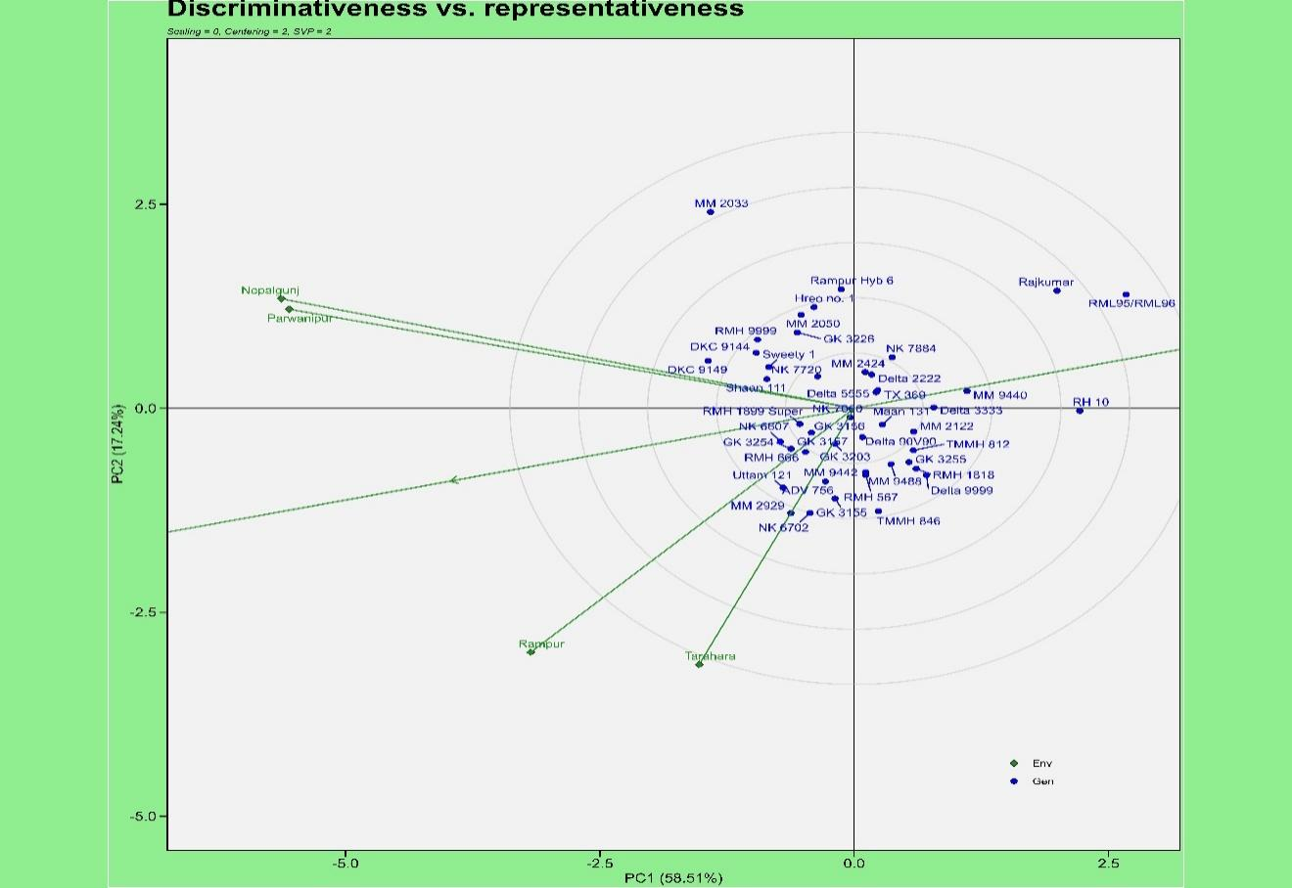

Figure 9 GGE Biplot illustrating the discriminativeness and representativeness of 45 maize hybrids across four locations over a two-Season (2019-2021)

* 1. **Stability and average yield performance of the varieties**

To assess the stability and average yield performance of the 45 Maize Hybrid varieties, the average environment coordination (AEC) approach was employed. The stability axis, represented by a double-headed arrow axis that intersects the biplot origin at a right angle to the AEC on the basis of singular value partitioning (SVP = 1), serves as a crucial indicator of genotype stability. The vertical axis (ordinate) of the biplot divides genotypes into two groups based on their average yield performance: those above and below the average. Genotypes located closest to the vertical stability axis displayed the most stable yield performance. These stable performers included RML-95/96, RH-10, Rajkumar, MM9440, Delta 333, Delta555, NK7660, RMH1899 super, Shan 111, and NK7660 *Figure 10*. Conversely, genotypes further away from the stability axis exhibited more unstable yield, characterized by significant fluctuations across environments. Examples of these unstable genotypes include MM2920, TMH846, MM2033, RH-6, Hero no 1, Delta 9999, and MM2050. It's crucial to note that stability alone does not guarantee success. Among the stable genotypes, several achieved both stability and high average yields. These high-performing, stable varieties included RML95/96, RH-10, MM9440, Delta-333, Tx-369, and Delta 5555. Other stable genotypes, such as NK7660, RMH1899 super, and GK3203, demonstrated stable but lower average yields.

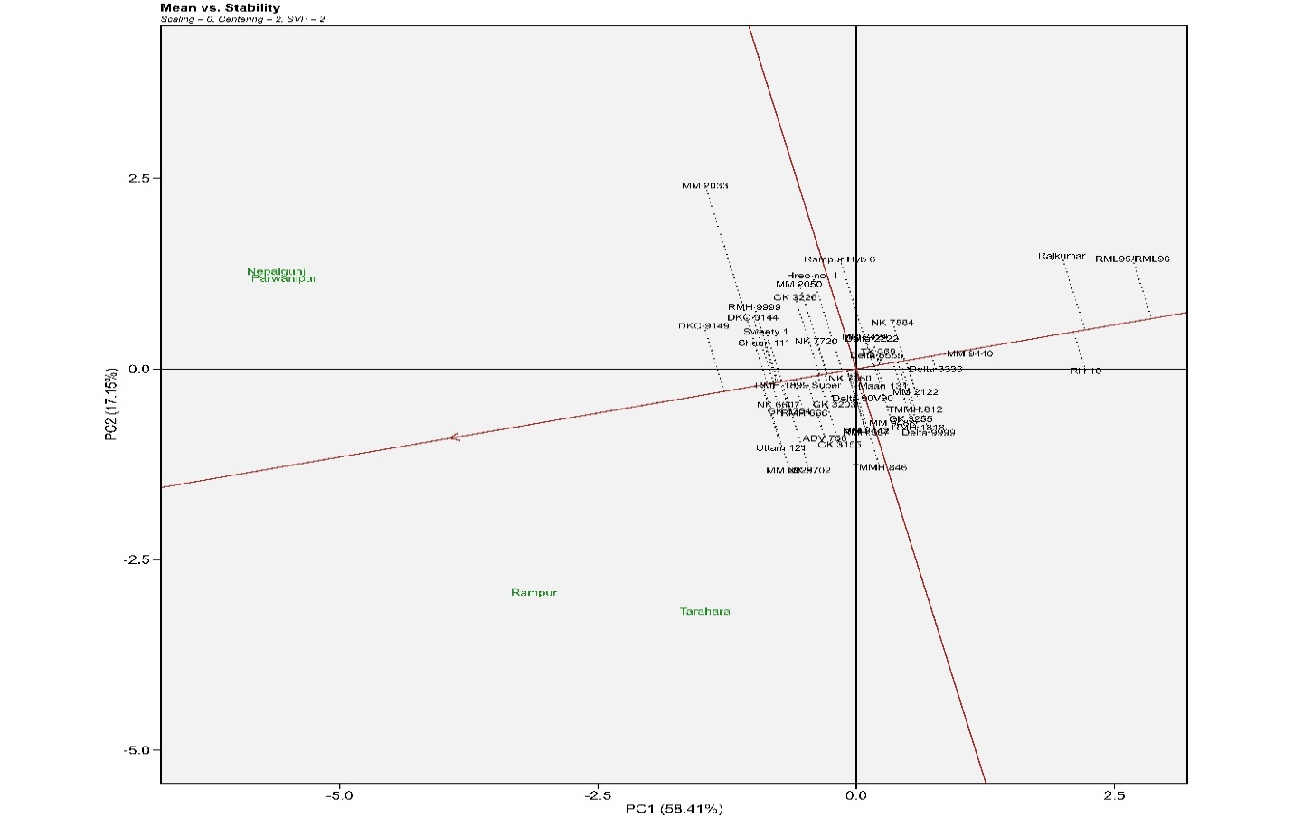

Figure 10 A GGE biplot illustrating the stability and yield performance of 45 maize hybrids across two seasons and four locations

* 1. **Ranking varieties relative to the ideal varieties**

An analysis of 45 maize varieties grown in four different environments using a GGE biplot revealed that varieties closer to the center of the concentric circles had higher average yields. Varieties GK3157, NK6607, RMH1899 Super, GK3254, RMH666, Shan 111, DKC9149 and Sweety-1 were identified as the most desirable varieties due to their high yields and lies first concentric circle proximity to the ideal genotype. Varieties NK6702, GK3155, MM944, Mann 131, Delta 5555, NK7720, MM2424, RMH999, DKC9144 located in the second concentric circle near the ideal genotype, exhibited both good yields and stability. Varieties MM9440, Hero no 1 positioned further from the ideal genotype, showed lower stability. Varieties RH10, Rajkumar, MM2033, RML95/96, RH-6, located outer side the concentric circles, had low yields and were considered unsuitable for further breeding cycles *Figure 11*.

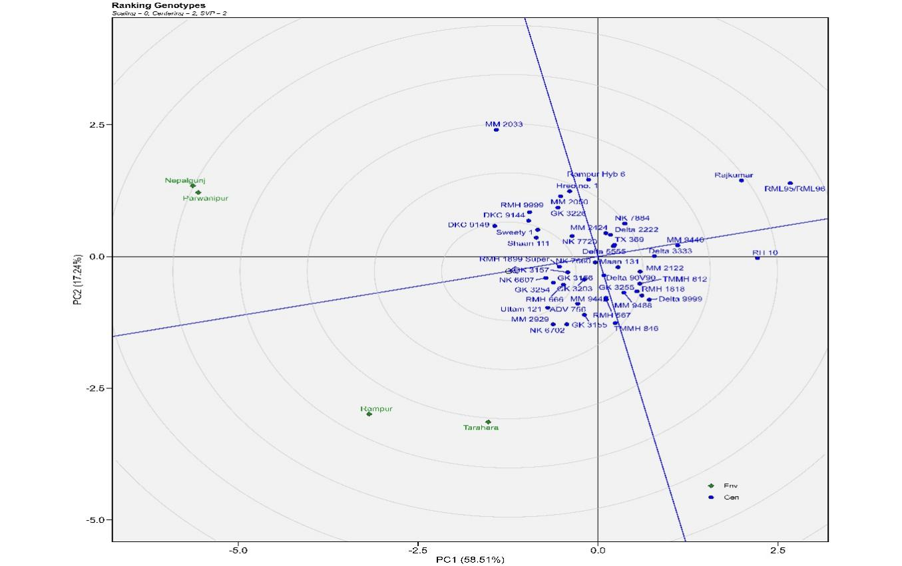

Figure 11 GGE plot depicting the Comparison and ranking of genotypes based on the ideal genotype of maize hybrids over 2 season 2019-2021.

* 1. **Best linear unbiased prediction (BLUP):**A substantial proportion of the traits examined displayed significant genotype-by-environment (GxE) interactions at a 5% significance threshold, as evaluated using the Likelihood Ratio Test (LRT) implemented in the gamem_met function of the metan R package. Variables with nonsignificant Genotype effect, Pant aspects, ear aspects, insect Score, Final plant Stands/ha Ear height, Plant height. This implies that these traits exhibit consistent expression across varying environmental conditions. Consequently, within this context, employing the BLUP (Best Linear Unbiased Prediction) approach is likely to yield more precise and dependable predictions of trait performance across diverse environments. The predicted mean values of the varieties for each of the significant GxE interaction studied traits are presented in figure 1 and 2. The Best Linear Unbiased Prediction (BLUP) plot delineates the superior performers and stabilized varieties for yield, with DKC9141, Uttam 121, NK6607, MM2929, and MM2023 emerging as top contenders. MM9442 exhibits a performance just above the yield threshold, indicating its potential. In contrast, RML-96, Rajkumar, RH-10, and Rampur Hybrid six display poor and unstable genotypes, rendering them unsuitable for further selection (*Figure 2*). A similar discernment is observed in the test grain weight domain, where NK7720, RMH66, and GK3255 stand out with the largest test grain weight, reaching up to 350 grams. Notably, NK6607 boasts the largest cob diameter, while GK3255 leads in cob length. On the contrary, TX369 to Shann 111 exhibit poor cob length, and MM24 to Delta 333 fall below the threshold value, warranting their exclusion from further evaluation.

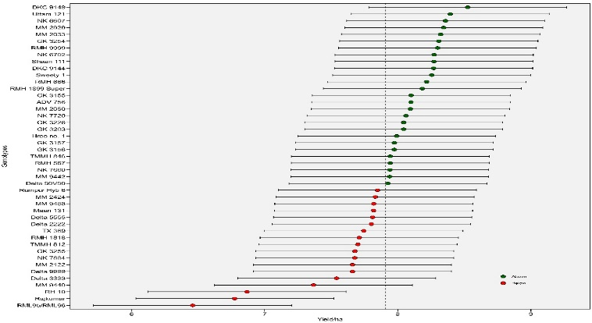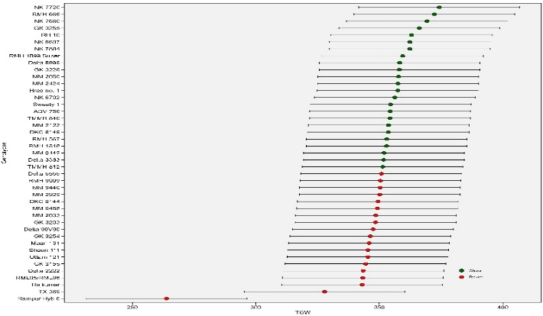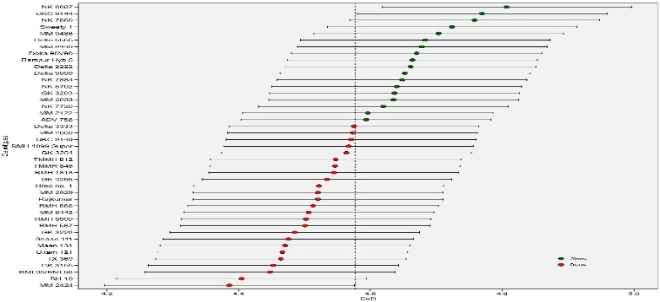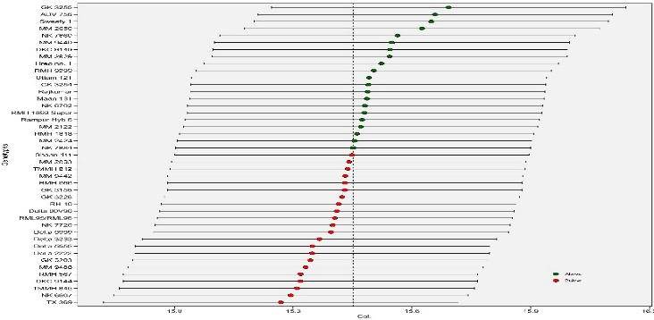

A

B

C

D

Figure 2 BLUP Plot illustrating the mean values of A: Yield per Hectare (Yield/ha), B: Thousand Grain Weight, C: Cob Diameter, and D: Cob Length across various hybrid varieties.

The assessment of anthesis duration reveals that Rampur Hybrid 6 requires more than 118 days, surpassing ADV-756 and DKC-9149 in duration. The mean value for the Days to Anthesis across the tested varieties is 112 days. Remarkably, Delta-9999 and Delta-5555 exhibit the shortest duration to anthesis and silking, both falling below 110 days after sowing (DAS). The BLUP mean value for the Days to Silking is approximately 114 days, providing a comprehensive understanding of the reproductive development timeline. In terms of Shelling Percentage, the mean value across the tested genotypes stands at 79%. Notably, Uttam-121, NK7884, and GK-3226 showcase the highest shelling percentages *Figure 3*. However, it is essential to highlight that MM2424 approaches the threshold value for shelling percentage, suggesting a critical evaluation of its suitability for further consideration.

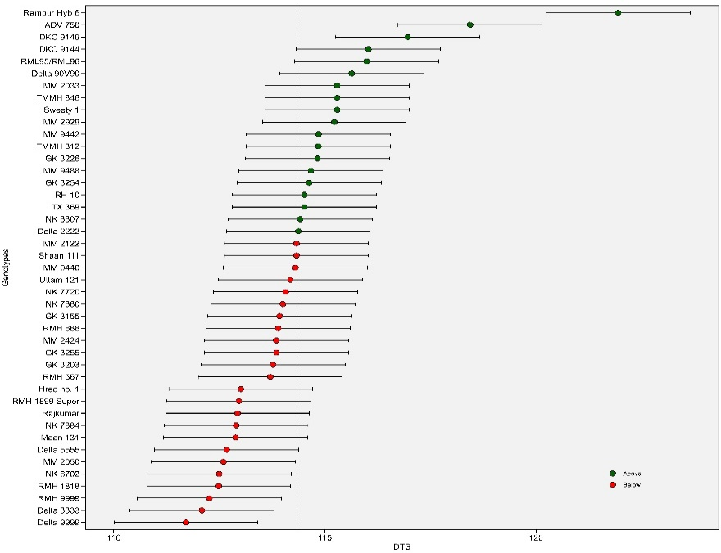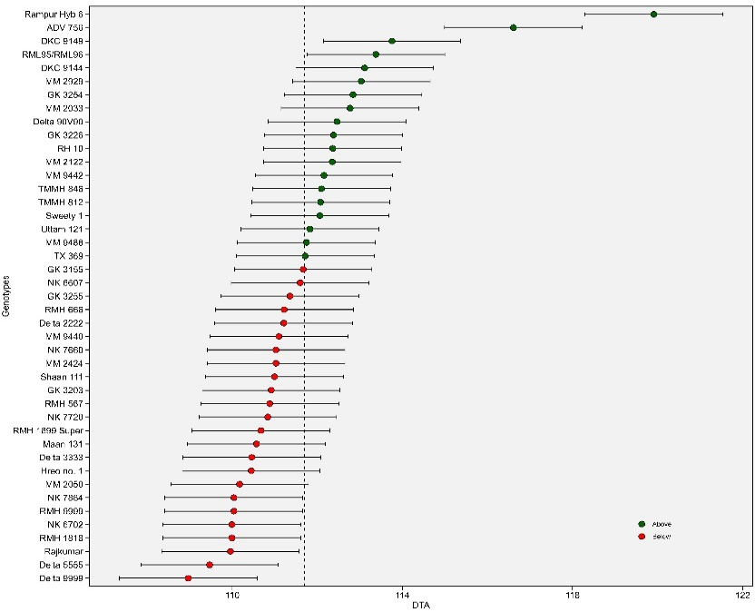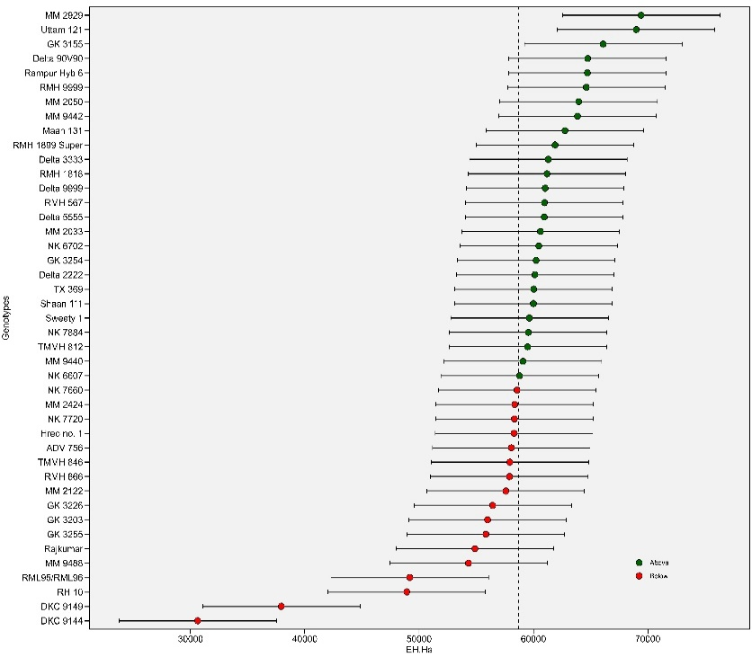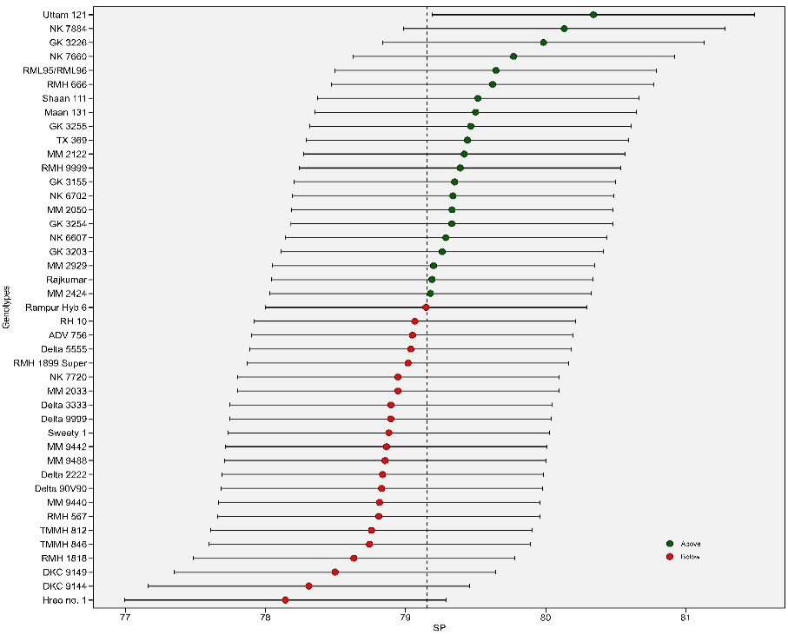

E

F

H

G

Figure 3 BLUP Plot representing the mean values for E: Day to Anthesis, F: Day to Silking, G: Ear per Hectare (Ear/Ha), and H: Shelling Percentage across diverse varieties.

* 1. **WAASBY model for Simultaneous selections for Yield and Stability**

This study introduces a novel quantitative stability measure called WAASB, proving its effectiveness in identifying genotypes that excel in both high productivity and broad adaptability across diverse environments. Analyzing four datasets exhibiting various GEI patterns, the researchers determined BLUP to be the most accurate predictive model for genotype performance. WAASB, coupled with yield data, revealed RMH-666, GK 3254, Uttam 121, and RMH-1899 as the top performers, demonstrating exceptional stability and yield. Conversely, RH-10, RML96/96, MM2033, and MM9440 were identified as underperforming and unstable under the tested conditions *Figure 4*.

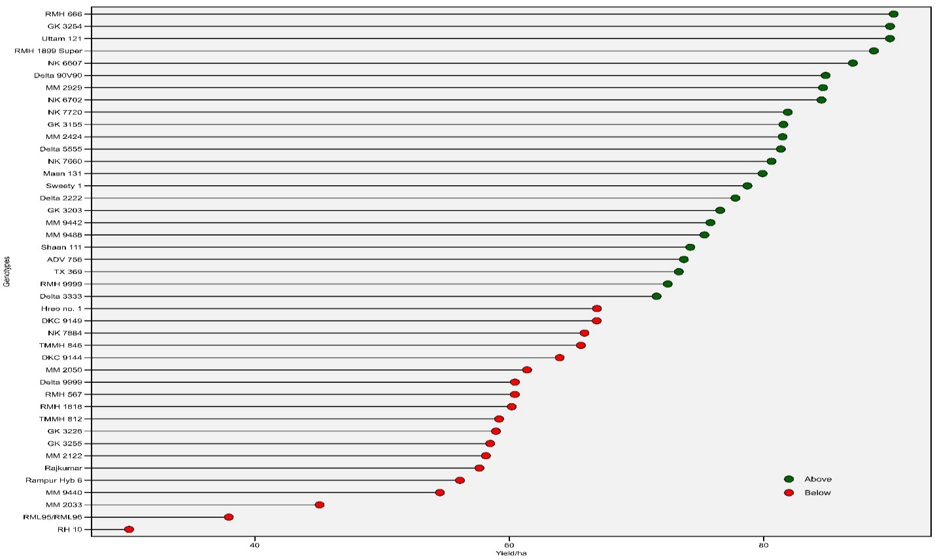

Figure 4 This figure reveals the stability of various maize genotypes in terms of yield (ha/unit) using the WAASB metric. Red-headed genotypes (unselected) exhibit lower WAASB values, indicating instability and potential discarding for further breeding programs.

* 1. **Plotting the heat map graphics for the** **WAASB index and WAASB/GY ratio**

This *Figure 5*presents two heatmaps that explore how maize genotypes are ranked according to different factors. The first one examines how rankings change based on the number of components used for stability analysis. The second reveals how rankings vary based on the balance between stability and yield, where 100/0 favors stability and 0/100 favors yield exclusively. A combined analysis of IPCA and WAASB/GY ratio revealed four distinct clusters of maize genotypes. The Red Cluster comprises genotypes characterized by both low productivity and instability, including DKC9144, DKC9149, Rampur Hybrid 6, MM2050, MM2033, RMH-567, and GK-3226. In contrast, the Blue Cluster encompasses genotypes that exhibit high productivity but are concurrently unstable, featuring Rajkumar, MM2122, MM9440, Delta-9999, TMMH-812, RMH-1818, and GK-3255. The Black Cluster is characterized by stable yet unproductive genotypes, such as RH-10 and RML-95/96. Finally, the Green Cluster comprises genotypes marked by both high productivity and stability, exemplified by MBS-1132, MBS-1144, Trivikram to Shree Ram 9696.

Figure 5 Ranks of genotypes illustrated by A) the number of Principal Components (PC) utilized for estimating the Weighted Average of Absolute Scores (WAAS), and B) the WAAS-to-Grain Yield (GY) ratio.

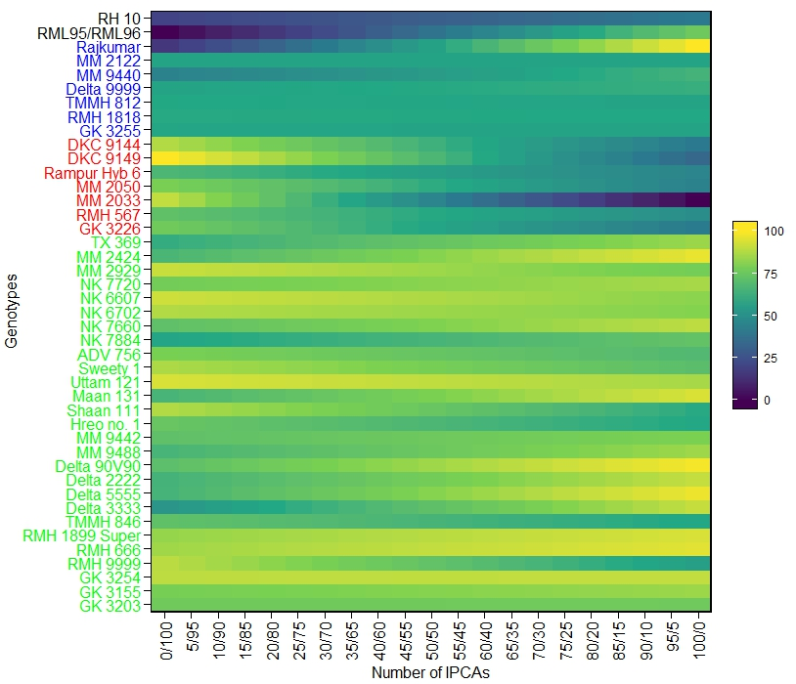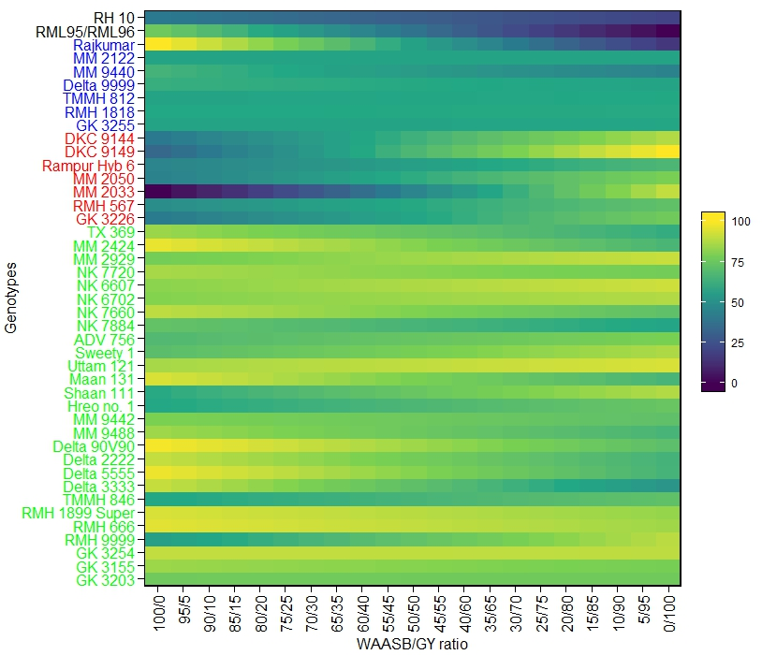

B

A

* 1. **Multi‑trait stability index (MTSI) for overall conditions.**

Using the Factorial analysis Multi Genotype Ideotype index (FAGMI), a method that ranks maize varieties based on their performance and stability across multiple important traits, this study identified nine superior varieties for farmers. Selecting the top 20%, the researchers found MM 2033, NK 6607, MM 2929, Sweety 1, NK 6702, NK 7660, Uttam 121, GK 3203, and MM 2050. These varieties, marked with red dots in the figure, are expected to be both productive and suitable for a wide environment.

Figure 12 Representation of Multi Trait stability index-Genotype Ranking of Hybrid maize over two seasons over 4 locations in Nepal at 20% selection intensity

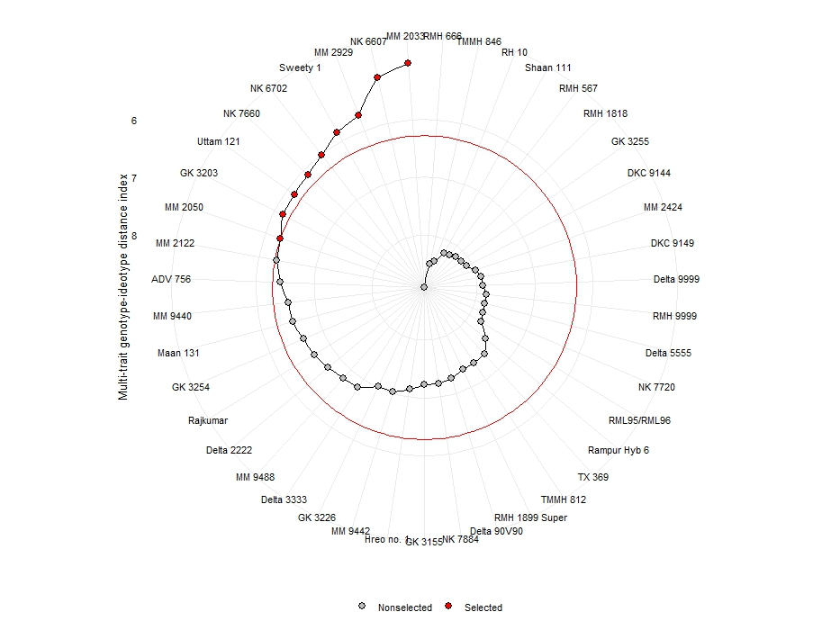

* 1. **Selection of the Cold wave Tolerant genotype based on MTSI.**

A study was conducted to identify maize varieties with superior performance under cold stress conditions. Seventeen hybrid varieties were initially selected based on their differential tolerance analysis (DTA) data, indicating tolerance to day temperatures of ≤10°C. Further evaluation using a multi-genotype ideotype index led to the selection of only three varieties (denoted by red dots) that demonstrated exceptional performance and stability. At 17% selection intensity, these superior varieties, namely GK3254, TMMH-846, and MM-9442, were chosen for their suitability for cultivation in environments with frequent cold waves. Interestingly, genotypes with days to anthesis exceeding 108 days exhibited an escape mechanism, as their flowering period coincided with a period of higher minimum day temperatures (13-15°C).

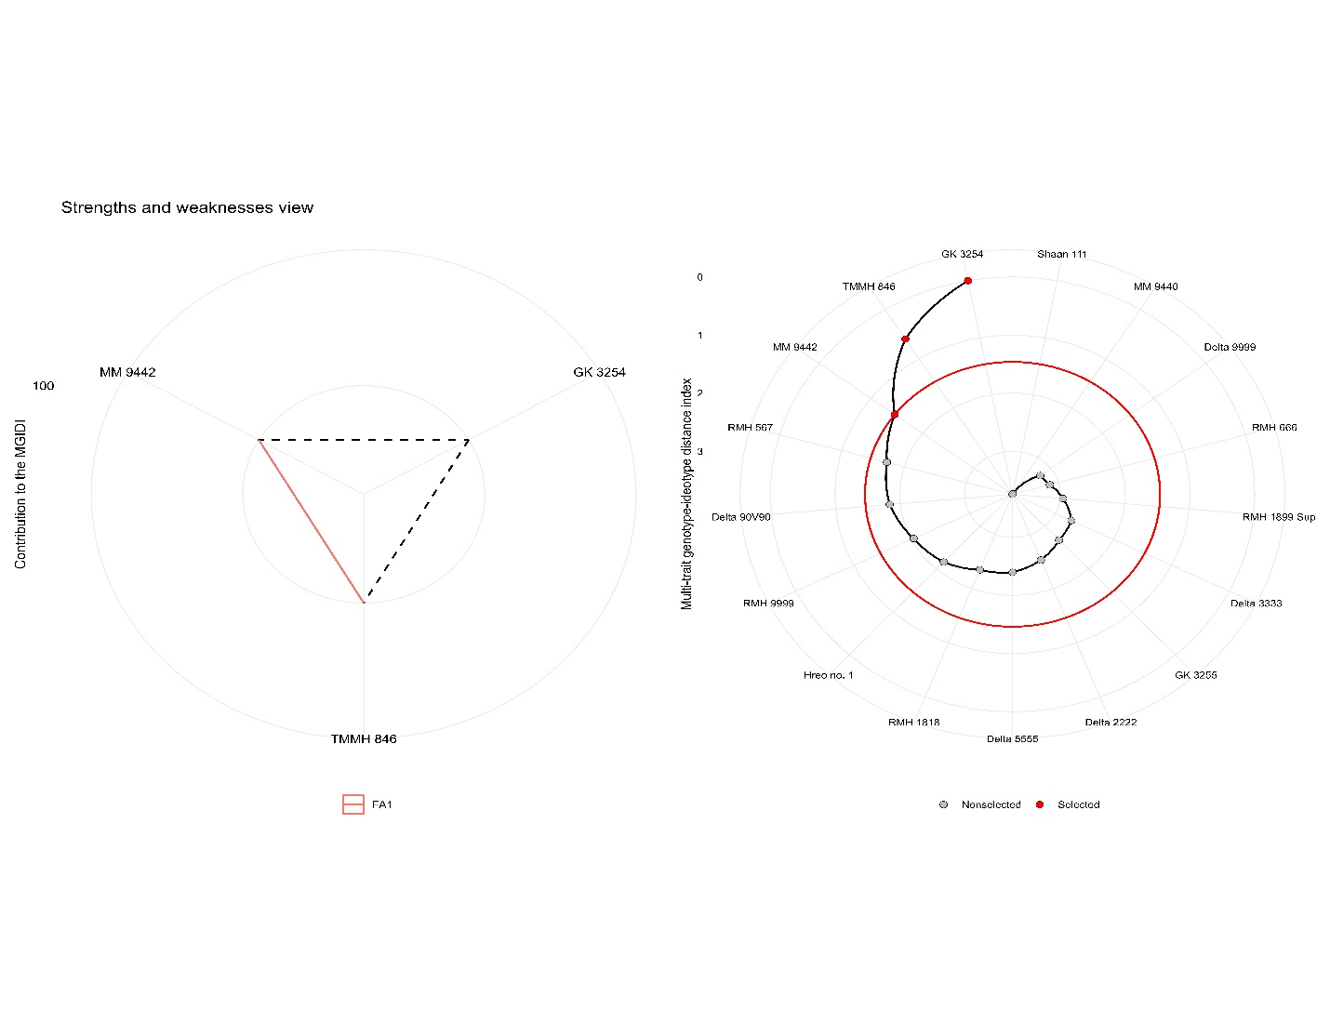

Figure 13 Impact of Cold Waves on Winter Maize Hybrid Selection (2019-2021) based on Days to anthesis and yield/ha.

1. **Conclusion**

This study conclusively emphasizes the crucial role of Genotype-Environment interaction (GEI) in breeding resilient and productive winter maize hybrid varieties for diverse Nepalese environments. Employing advanced statistical tools, the research identified superior hybrids exhibiting both high average yields and adaptability across locations. Champions like GK3157, NK6607, and DKC9141 emerged as top performers across most environments, while others like Delta 3333 and Rampur Hybrid 6 displayed region-specific suitability. Based on multi genotypes ideotype distance indexing, MM2033 identified as most stable and superior performer. Additionally, promising candidates for cold waves GK3254, TMMH-846, and MM-9442 were identified, highlighting the potential for targeted recommendations based on regional needs. Implementing these findings can substantially optimize winter maize yield at the farmer level, contributing to food security and economic well-being in Nepal.

**Author Contribution statement:**

"C.B. K: Investigation, writing—original draft preparation, project administration; Supervision; B.B: Investigation, Methodology, software, validation, data curation; writing—review and editing. S.S: investigation; D.N.M: investigation; R.C: investigation; J.U: investigation; P.P: investigation. All authors reviewed the manuscript."

**Data availability**

The data that support the findings of this study are available from the corresponding author upon reasonable request.

**Competing interests**

The authors declare no competing interests

**No funding and Grant were received by this Project.**

**Supplementary Materials information**

Mean of all traits associated genotypes- **S1(Data)**

Contribution factor rank of all genotypes -**S2**

Contribution factor rank of selected genotypes -**S3**

Factorial analysis loading -**S4**

Descriptive statistics of all Traits-**S5**

AMMI analysis verified chart -**S6**

Likehood Ratio Test-**S7**

References:

Adham, A., Ghaffar, M. B. A., Ikmal, A. M., & Shamsudin, N. A. A. (2022). Genotype × Environment Interaction and Stability Analysis of Commercial Hybrid Grain Corn Genotypes in Different Environments. *Life*, *12*(11). https://doi.org/10.3390/life12111773

Basnet, B., & Khanal, S. (2022). Quantitative trait loci and candidate genes for iron and zinc bio-fortification in genetically diverse germplasm of maize (Zea mays L): A systematic review. *Heliyon*, *8*(12). https://doi.org/10.1016/j.heliyon.2022.e12593

Benakanahalli, N. K., Sridhara, S., Ramesh, N., Olivoto, T., Sreekantappa, G., Tamam, N., Abdelbacki, A. M. M., Elansary, H. O., & Abdelmohsen, S. A. M. (2021). A Framework for Identification of Stable Genotypes Basedon MTSI and MGDII Indexes: An Example in Guar (Cymopsis tetragonoloba L.). *Agronomy*, *11*(6), 1221. https://doi.org/10.3390/agronomy11061221

Beswa, D., Siwela, M., Amonsou, E. O., & Kolanisi, U. (2020). Grain quality, provitamin a carotenoid profiles, and sensory quality of provitamin a-biofortified maize stiff porridges. *Foods*, *9*(12). https://doi.org/10.3390/foods9121909

Erenstein, O., Jaleta, M., Sonder, K., Mottaleb, K., & Prasanna, B. M. (2022). Global maize production, consumption and trade: trends and R&D implications. *Food Security*, *14*(5), 1295–1319. https://doi.org/10.1007/s12571-022-01288-7

Esan, V. I., Oke, G. O., Ogunbode, T. O., & Obisesan, I. A. (2023). AMMI and GGE biplot analyses of Bambara groundnut [Vigna subterranea (L.) Verdc.] for agronomic performances under three environmental conditions. *Frontiers in Plant Science*, *13*(January), 1–18. https://doi.org/10.3389/fpls.2022.997429

Gairhe, S., Timsina, K. P., Ghimire, Y. N., Lamichhane, J., Subedi, S., & Shrestha, J. (2021). Production and distribution system of maize seed in Nepal. *Heliyon*, *7*(4), 1–12. https://doi.org/10.1016/j.heliyon.2021.e06775

Gauch, H. G. (2013). A simple protocol for AMMI analysis of yield trials. *Crop Science*, *53*(5), 1860–1869. https://doi.org/10.2135/cropsci2013.04.0241

Gebreselassie, H., Tesfaye, B., Gedebo, A., & Tolessa, K. (2023). Genotype by environment interaction and stability analysis using AMMI and GGE-biplot models for yield of Arabica coffee genotypes in south Ethiopia. *Journal of Crop Science and Biotechnology*, *Tefera 2022*. https://doi.org/10.1007/s12892-023-00213-4

Haberer, G., Young, S., Bharti, A. K., Gundlach, H., Raymond, C., Fuks, G., Butler, E., Wing, R. A., Rounsley, S., Birren, B., Nusbaum, C., Mayer, K. F. X., & Messing, J. (2005). Structure and architecture of the maize genome. *Plant Physiology*, *139*(4), 1612–1624. https://doi.org/10.1104/pp.105.068718

Khan, M. M. H., Rafii, M. Y., Ramlee, S. I., Jusoh, M., & Al Mamun, M. (2021). AMMI and GGE biplot analysis for yield performance and stability assessment of selected Bambara groundnut (Vigna subterranea L. Verdc.) genotypes under the multi-environmental trails (METs). *Scientific Reports*, *11*(1), 1–17. https://doi.org/10.1038/s41598-021-01411-2

Krishnamurthy, S. L., Sharma, P. C., Sharma, D. K., Ravikiran, K. T., Singh, Y. P., Mishra, V. K., Burman, D., Maji, B., Mandal, S., Sarangi, S. K., Gautam, R. K., Singh, P. K., Manohara, K. K., Marandi, B. C., Padmavathi, G., Vanve, P. B., Patil, K. D., Thirumeni, S., Verma, O. P., … Singh, R. K. (2017). Identification of mega-environments and rice genotypes for general and specific adaptation to saline and alkaline stresses in India. *Scientific Reports*, *7*(1), 1–14. https://doi.org/10.1038/s41598-017-08532-7

Munda, S., Paw, M., Saikia, S., Begum, T., Baruah, J., & Lal, M. (2023). Stability and selection of trait specific genotypes of Curcuma caesia Roxb.using AMMI, BLUP, GGE, WAAS and MTSI model over three years evaluation. *Journal of Applied Research on Medicinal and Aromatic Plants*, *32*(November 2022). https://doi.org/10.1016/j.jarmap.2022.100446

Ndhlela, T., Herselman, L., Magorokosho, C., Setimela, P., Mutimaamba, C., & Labuschagne, M. (2014). Genotype × environment interaction of maize grain yield using AMMI biplots. *Crop Science*, *54*(5), 1992–1999. https://doi.org/10.2135/cropsci2013.07.0448

Olivoto, T., & Lúcio, A. D. C. (2020). metan: An R package for multi-environment trial analysis. *Methods in Ecology and Evolution*, *11*(6), 783–789. https://doi.org/10.1111/2041-210X.13384

Olivoto, T., Lúcio, A. D. C., da Silva, J. A. G., Marchioro, V. S., de Souza, V. Q., & Jost, E. (2019). Mean performance and stability in multi-environment trials i: Combining features of AMMI and BLUP techniques. *Agronomy Journal*, *111*(6), 2949–2960. https://doi.org/10.2134/agronj2019.03.0220

Olivoto, T., & Nardino, M. (n.d.). *Supporting Informatin for MGIDI : towards an effective multivariate selection in biological experiments by List of Figures*. 1–50.

Olivoto, T., & Nardino, M. (2021). *Genetics and population analysis MGIDI : toward an effective multivariate selection in biological experiments*. *37*(December 2020), 1383–1389. https://doi.org/10.1093/bioinformatics/btaa981

Olivoto, T., Nardino, M., Meira, D., Meier, C., Follmann, D. N., de Souza, V. Q., Konflanz, V. A., & Baretta, D. (2021). Multi-trait selection for mean performance and stability in maize. In *Agronomy Journal* (Vol. 113, Issue 5, pp. 3968–3974). https://doi.org/10.1002/agj2.20741

Promotion, A., Division, S., Section, S., & Durbar, S. (2012). *Statistical Information on Statistical Information on*. *2012*.

Rakshit, S., Ganapathy, K. N., Gomashe, S. S., Rathore, A., Ghorade, R. B., Kumar, M. V. N., Ganesmurthy, K., Jain, S. K., Kamtar, M. Y., Sachan, J. S., Ambekar, S. S., Ranwa, B. R., Kanawade, D. G., Balusamy, M., Kadam, D., Sarkar, A., Tonapi, V. A., & Patil, J. V. (2012). GGE biplot analysis to evaluate genotype, environment and their interactions in sorghum multi-location data. *Euphytica*, *185*(3), 465–479. https://doi.org/10.1007/s10681-012-0648-6

SHAO, R. xin, YU, K. ke, LI, H. wei, JIA, S. jie, YANG, Q. hua, ZHAO, X., ZHAO, Y. li, & LIU, T. xue. (2021). The effect of elevating temperature on the growth and development of reproductive organs and yield of summer maize. *Journal of Integrative Agriculture*, *20*(7), 1783–1795. https://doi.org/10.1016/S2095-3119(20)63304-4

Shrestha, S., Peel, M. C., & Moore, G. A. (2023). Cold waves in Terai region of Nepal and farmer’s perception of the effect of fog events and cold waves on agriculture. *Theoretical and Applied Climatology*, *151*(1–2), 29–45. https://doi.org/10.1007/s00704-022-04262-7

Singh, C., Gupta, A., Gupta, V., Kumar, P., Sendhil, R., Tyagi, B. S., Singh, G., Chatrath, R., & Singh, G. P. (2019). Genotype x environment interaction analysis of multi-environment wheat trials in India using AMMI and GGE biplot models. *Crop Breeding and Applied Biotechnology*, *19*(3), 309–318. https://doi.org/10.1590/1984-70332019v19n3a43

Taleghani, D., Rajabi, A., Saremirad, A., & Fasahat, P. (2023). Stability analysis and selection of sugar beet ( Beta vulgaris L .) genotypes using AMMI , BLUP , GGE biplot and MTSI. *Scientific Reports*, 1–14. https://doi.org/10.1038/s41598-023-37217-7

Tranel, D., Knapp, A., & Perdomo, A. (2009). Chilling effects during maize tassel development and the lack of compensational plasticity. *Crop Science*, *49*(5), 1852–1858. https://doi.org/10.2135/cropsci2008.10.0593

*WAASB based stability analysis and simultaneous selection for grain yield and early maturity in soybean*. (n.d.). https://doi.org/10.1002/agj2.20750.This

Wang, H., Nussbaum-wagler, T., Li, B., Zhao, Q., Vigouroux, Y., Faller, M., Bomblies, K., Lukens, L., & Doebley, J. F. (2005). *The origin of the naked grains of maize*. *436*(August). https://doi.org/10.1038/nature03863

Waqas, M. A., Wang, X., Zafar, S. A., Noor, M. A., Hussain, H. A., Azher Nawaz, M., & Farooq, M. (2021). Thermal stresses in maize: Effects and management strategies. *Plants*, *10*(2), 1–23. https://doi.org/10.3390/plants10020293

Wei, F., Coe, E., Nelson, W., Bharti, A. K., Engler, F., Butler, E., Kim, H. R., Goicoechea, J. L., Chen, M., Lee, S., Fuks, G., Sanchez-Villeda, H., Schroeder, S., Fang, Z., McMullen, M., Davis, G., Bowers, J. E., Paterson, A. H., Schaeffer, M., … Wing, R. A. (2007). Physical and genetic structure of the maize genome reflects its complex evolutionary history. *PLoS Genetics*, *3*(7), 1254–1263. https://doi.org/10.1371/journal.pgen.0030123

Yan, W., & Tinker, N. A. (2006). Biplot analysis of multi-environment trial data: Principles and applications. *Canadian Journal of Plant Science*, *86*(3), 623–645. https://doi.org/10.4141/P05-169

Yang, C. J., Samayoa, L. F., Bradbury, P. J., Olukolu, B. A., Xue, W., York, A. M., Tuholski, M. R., Wang, W., Daskalska, L. L., Neumeyer, M. A., de Jesus Sanchez-Gonzalez, J., Romay, M. C., Glaubitz, J. C., Sun, Q., Buckler, E. S., Holland, J. B., & Doebley, J. F. (2019). The genetic architecture of teosinte catalyzed and constrained maize domestication. *Proceedings of the National Academy of Sciences of the United States of America*, *116*(12), 5643–5652. https://doi.org/10.1073/pnas.1820997116

Biointeractive (2015) Popped secret: The mysterious origin of corn - hhmi biointeractive video, YouTube. Available at: https://youtu.be/mBuYUb_mFXA?si=NqfJ7x7u8cG71TO9 (Accessed: 02 January 2024).

Shahbandeh, M. (2023) Corn production by country 2022/23, Statista. Available at: https://www.statista.com/statistics/254292/global-corn-production-by-country/ (Accessed: 02 January 2024).

Republica (2018) 12,000 farmers incur loss of Rs 107 million, My Republica. Available at: https://myrepublica.nagariknetwork.com/news/12-000-farmers-incur-loss-of-rs-107-million/ (Accessed: 02 January 2024).